**Creating Microservices for account and loan**

Cleaning package for account microservice:

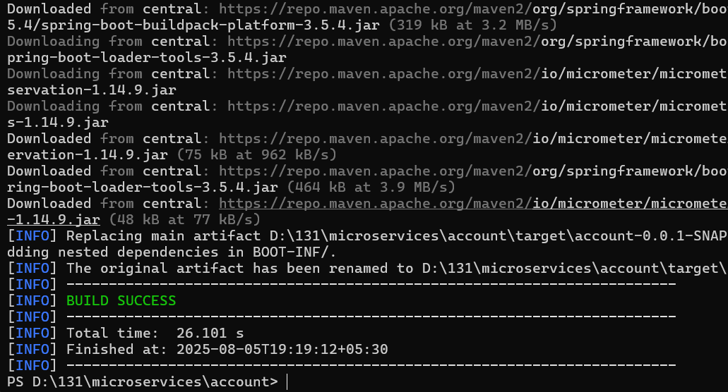

src/main/java/com/cognizant/account/controller/AccountController.java:

package com.cognizant.account.controller;

import org.springframework.web.bind.annotation.*;

import java.util.*;

@RestController

public class AccountController {

@GetMapping("/accounts/{number}")

public Map<String, Object> getAccountDetails(@PathVariable String number) {

Map<String, Object> account = new HashMap<>();

account.put("number", number);

account.put("type", "savings");

account.put("balance", 234343);

return account;

}

}

Testing in browser http://localhost:8080/accounts/00987987973432:

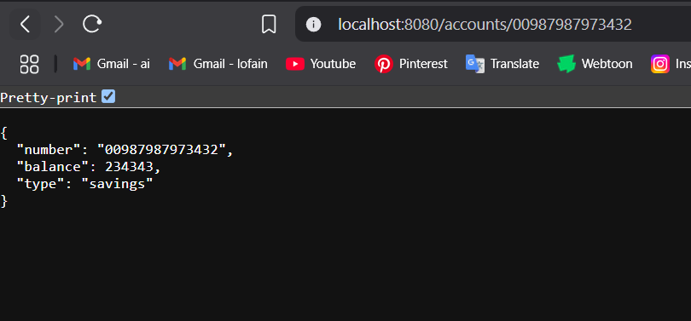

Cleaning package for loan microservice:

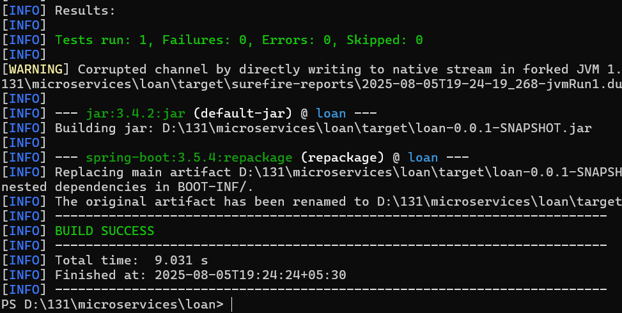

src/main/java/com/cognizant/loan/controller/LoanController.java:

package com.cognizant.loan.controller;

import org.springframework.web.bind.annotation.*;

import java.util.*;

@RestController

public class LoanController {

@GetMapping("/loans/{number}")

public Map<String, Object> getLoanDetails(@PathVariable String number) {

Map<String, Object> loan = new HashMap<>();

loan.put("number", number);

loan.put("type", "car");

loan.put("loan", 400000);

loan.put("emi", 3258);

loan.put("tenure", 18);

return loan;

}

}

src/main/resources/application.properties:

spring.application.name=loan

server.port=8081